Lab 3: Structure, Bonding, Polarity Review

Objective: Relate bonding, structure, and polarity.

Key Questions:

1. An atom is by definition a neutral species, what does that mean regarding the number of protons, neutrons and electrons that it possesses? - It means that there is an equal number of protons, neutrons, and electrons, so that the net charge is 0. The equal number of neutrons is so that we cannot say it is an isotope, but if it was an isotope, it would still have a net charge of 0.
2. If a cation is positively charged what does that mean regarding the number of protons, neutrons and electrons that it possesses? - The number of protons is greater than the number of electrons.
3. If an anion is negatively charged what does that mean regarding the number of protons, neutrons and electrons that it possesses? - The number of electrons is greater than the number of protons.
4. What is the general trend for electronegativity left to-right across a given row? - As you move from left to right across the periodic table, the element’s electron clouds become smaller, there is higher ionization energy, and higher electronegativity.
5. What is the general trend for electronegativity top to bottom down a given column? - As we move down the periodic table, the electron clouds/ atomic radius become bigger, there is lower ionization energy and a lower electronegativity.
6. Do the general trends show exceptions? If so identify one of those exceptions by identifying the elements involved and state if it is an exception to the left-to-right trend or an exception to the top-to-bottom trend. - Oxygen is to the left of nitrogen, but the radius of oxygen is greater than that of nitrogen.
7. Why would two atoms with an electronegativity difference of 0 be expected to covalently bond (if bonding between them is possible)?- Because they will most likely both have a similar number of electrons, so they would most likely want to share their electrons, also known as covalent bonding.
8. What atoms that have an electronegativity difference of zero will not form covalent bonds between themselves?- K and Rb because they both only have 1 electron, but both their electronegativity numbers are 0.82.
9. What does it suggest occurs between two nearby atoms when their electronegativity difference is 2.0 or more?- They will not form a covalent bond, but more likely a ionic or metallic.
10. For the following atom pairs, determine the electronegativity difference and predict the expected bonding type between them. (Create and complete the table in your team's notes.)-

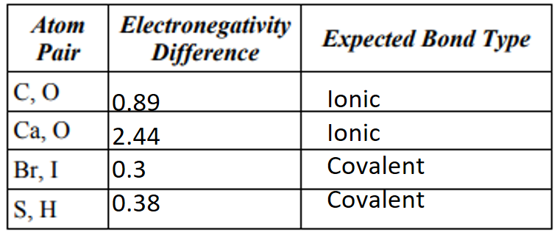

1. For the following bonding pairs, show the direction of the bond dipole using a crossed arrow, if the bonding atom pair would form a polar colvalent bond. If not they would not form a polar covalent write N/A. (Create and complete the table in your team's notes.)-

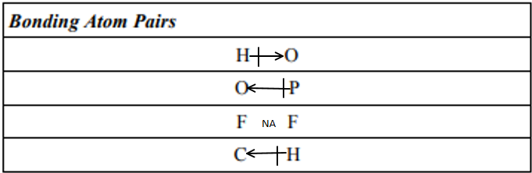

1. Construct the Lewis structure of CCl4

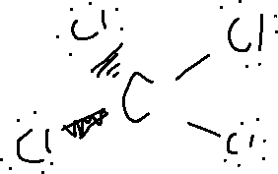

1. Construct the Lewis structure of CO2

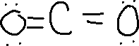

1. Construct the Lewis structure of SO2

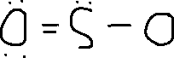

1. Determine the electronic and molecular geometries of CCl4 – Tetrahedral, tetrahedral
2. Determine the electronic and molecular geometries of CO2- linear, linear
3. Determine the electronic and molecular geometries of SO2 – trigonal planar, bent
4. Why was the y-vector above given a negative measurement? – It has a vector pointing down, and we assume that on a 2d plane, much like on a normal graph, moving left and down are considered negative.
5. What equation could be used to determine the length of the xy-vector above when the lengths of the x-component and y-component are know? – We could use the Pythagorean Theorem, or a2+b2=c2
6. Determine the molecular dipole of CO2

none

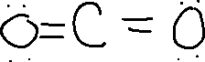

1. Determine the molecular dipole of SO2

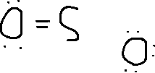

1. Determine the molecular dipole of CCl4

none

